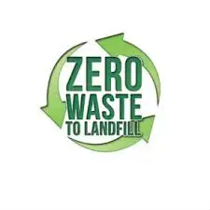

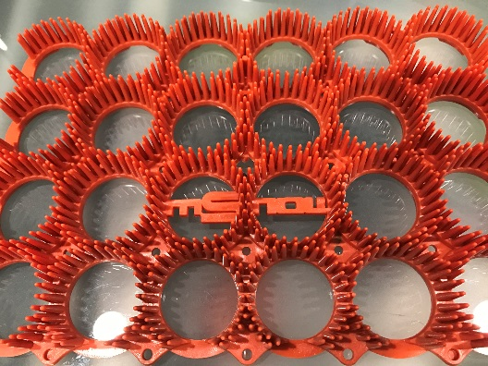
CHAIRLIFT ORANGE mSNOW™ 2023 - $8.35/sf
- Engineered specifically for use on wintertime chairlift load/unload ramps
- Made from recycled road construction barrels
- Highly-durable, impact-resistant plastic lasts for many years, UV-inhibitors for maximum sunlight resistance
- Extremely low cold-cracking temperature
- 100% Recyclable and Made in Michigan, USA
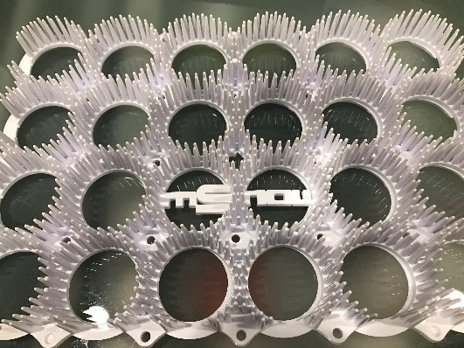
COMMERCIAL WHITE mSNOW™ 2023 - $15.25/sf
- Guaranteed pure white in color
- All the same material qualities of the Recycled Orange, but with extra additives for low coefficient of friction, maximum UV protection, and extremely low cold-cracking temperature
- Custom color matching is available
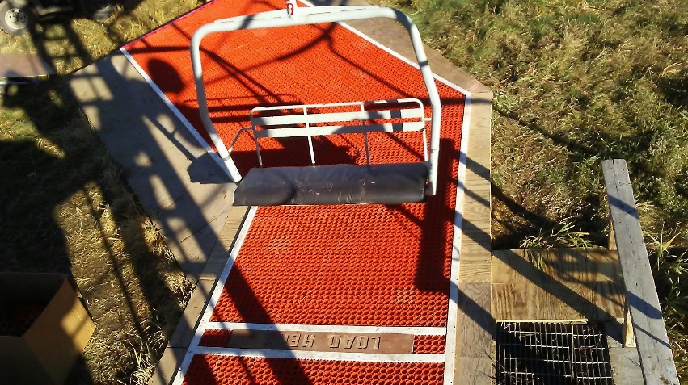
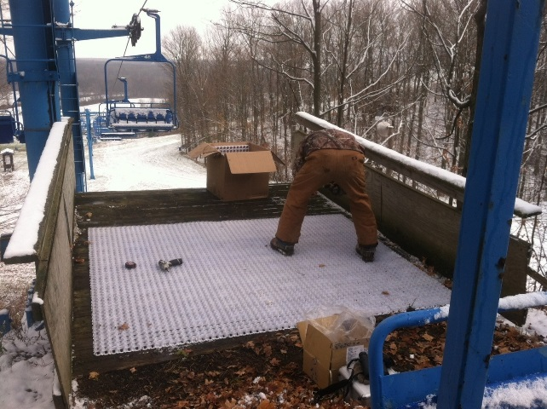
- 100% Recyclable and Made in Michigan, USA
Be sure to ask about our volume discounts!!!

